QA - Automation and Development

Part 2 and Part 3

**Name:** Rotem Bussani.

**ID:** 312118946

**Email:** [RotemBussani@Gmail.com](mailto:RotemBussani@Gmail.com)

**Name of course:** QA- Automation and development.

Table of Contents

**1. Abstract: 3**

**1.1 Website Test: 3**

**1.2 Appium Test: 4**

**1.3 SQL Test: 4**

**2. Methods: 5**

**2.1 Tests Performed using Selenium: 5**

**2.2 Tests Performed using Appium: 7**

**2.3 Tests Performed using SQLite: 8**

**3. Summery and conclusion: 9**

**4. Bibliography 10**

# Abstract:

## Website Test:

“Otsar Ha-Hayal” (Figure ‎1‑1) is a bank that primarily serves military personnel, veterans, and their families. Founded in 1949, the bank offers a range of financial services including deposits, loans, investments, and insurance. “Otsar Ha-Hayal” has over 40 branches across Israel and provides online banking services to its customers. The bank's mission is to provide financial solutions tailored to the unique needs of its clients, and to support the development and growth of the Israeli military and defense sector. (Bank "Otsar Ha-Hayal", n.d.)

Figure ‎1‑1: “Otsar Ha-Hayal” Logo

Testing a website is an essential step in ensuring that it functions as intended and provides a positive user experience. With the rise of online banking, it is crucial to develop and maintain a website that is secure, reliable, and user-friendly. Selenium is a widely used open-source tool that automates web browser interactions and enables testing of web applications across multiple platforms and browsers.



Figure ‎1‑2: Example for a button

Figure ‎1‑3: Log in frame

In this report, we will describe the process of testing the website of the bank " Otsar Ha-Hayal " using Selenium and Java and present the results of our tests. Our focus was on testing different navigation paths (using different ways to navigate such as Figure ‎1‑2 and Figure ‎1‑3). By automating these tests using Selenium and Java, we were able ensure the security and reliability of the website. Through this study, we aim to demonstrate the importance of testing web applications and provide insights into the use of Selenium and Java in the testing process.

## Appium Test:

Testing a memory game application is a crucial step in ensuring the quality and reliability of the software. With the increasing popularity of mobile devices, it is more important than ever to develop mobile applications that provide a seamless user experience and perform consistently under various conditions. Appium is a popular open-source tool that enables automated testing of mobile applications on multiple platforms, including Android and iOS. In this report, we will describe the process of testing a memory game application taken from GitHub (open source), (GitHub: Memory Game, n.d.), using Appium and Java and present the results of our tests.

Figure ‎1‑4: Sound ON/OFF Button

Figure ‎1‑5: Game Timer

We began by developing test cases to evaluate the functionality (Examples: Figure ‎1‑4,Figure ‎1‑5) and performance of the memory game application, including user interaction, game logic, and data storage. Using Appium and Java, we automated the execution of these test cases and recorded the results to identify any defects or errors in the application. Through this study, we aim to demonstrate the importance of testing mobile applications and provide insights into the use of Appium and Java in the testing process.

## SQL Test:

Facebook (Figure ‎1‑6) is a social media platform that was founded in 2004 by Mark Zuckerberg. The website's primary purpose is to connect people and allow them to share information and communicate with each other online. The Facebook website and mobile app offer a range of functions, including:

* User registration and login.
* Profile management.
* News feed and timeline display.
* Messaging and chat.
* Media sharing (photos, videos, etc.).

Figure ‎1‑6: Facebook Logo

* Groups and events creation and management.

(Facebook Login and Sign in page, n.d.).

The development of a website or application as complex as Facebook involves not only front-end design and user experience, but also back-end architecture and database management. Testing is a crucial step in ensuring the functionality, performance, and security of the system, and SQL (Structured Query Language) is a widely used tool for managing relational databases and performing operations on them, such as creating, reading, updating, and deleting records.

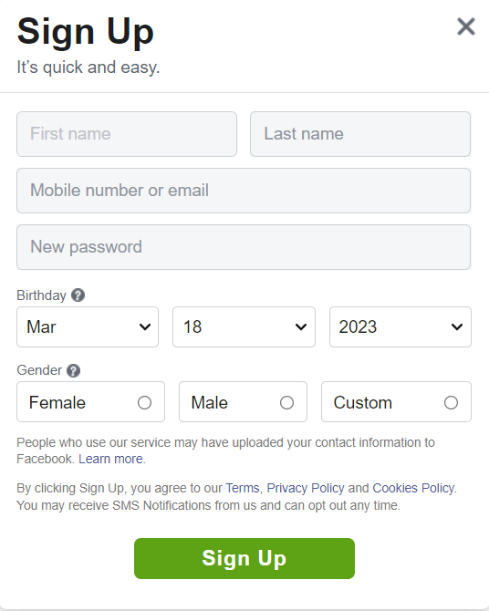In this report, we will describe the process of testing the user class for Facebook (Figure ‎1‑7) using SQLite and Java and present the results of our tests. We began by creating a database using Java and SQLite and implemented the CRUD (Create-Read-Update-Delete) operations to manage user data. We verified the data integrity and consistency of the system and evaluated its performance and scalability under various scenarios. Finally, we identified potential issues and suggested improvements to enhance the overall quality of the system. Through this study, we aim to contribute to the knowledge and practice of SQL testing in software development.

Figure ‎1‑7: Facebook Sign Up Page

# Methods:

## Tests Performed using Selenium:

Tests description for website tests can be seen in Table ‎2‑1.

Table ‎2‑1: Website tests using Selenium and Java

|  |  |  |  |
| --- | --- | --- | --- |
| **Name Of Test** | **Description** | **Failed/Succeeded** | **Note** |
| testUrl | opened URL is equals to the expected URL | V |  |
| HomePageNavigation | pressing the logo navigates to the home page | V | +taking a snapshot |
| scrollPage | Scrolling bar works properly and take snapshots | V |  |
| testActionsOnPage | tests buttons: back, forward, refresh and opening a new window. | V |  |
| openANewTab | opening of a new tab | V | + navigating to new tab |
| searchWebsite | searching and text printing | V | +taking a snapshot |
| testAlerts | tests invalid details and the error Message | V | +use wait |
| dropdown | opening a window, scrolling down and picking a specific option from a dropdown element. | V |  |
| testCheckBox | tests a checkbox element | V |  |
| testBookAVacation | booking of a vacation can be complete successfully | V |  |

All website tests succeeded as can be seen in Figure ‎2‑1.

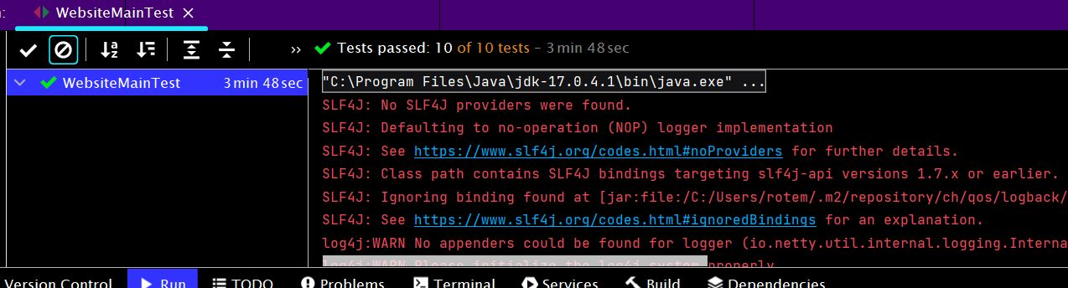

Figure ‎2‑1: Website Tests success

For example, one of the tests (searchWebsite) is opening a Wikipedia page and search for “משפחה” and get a text from the site. in Figure ‎2‑2 you can see the result we get on the web site, and in Figure ‎2‑3 we can see that the test passed and printed the text.

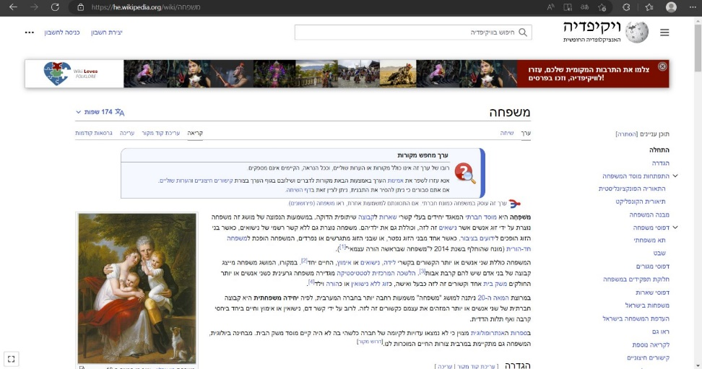

Figure ‎2‑2: Opened website by searchWebsite test

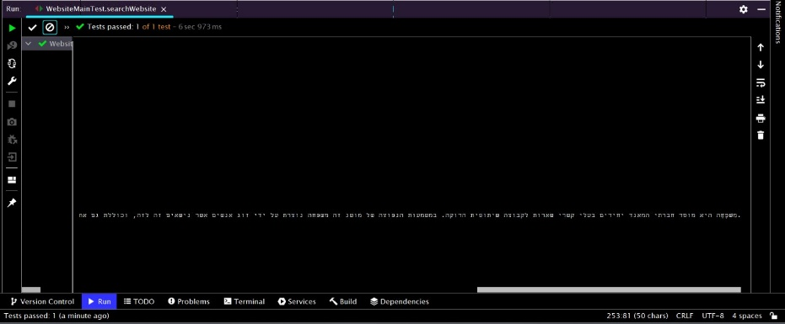

Figure ‎2‑3: Method searchWebsite finished Successfully.

## Tests Performed using Appium:

Tests description for memory game application tests can be seen in Table ‎2‑2.

Table ‎2‑2: Application tests using Appium and Java

|  |  |  |  |
| --- | --- | --- | --- |
| **Name Of Test** | **Description** | **Failed/Succeeded** | **Note** |
| testGameStarts | game has started | V |  |
| testNumberOfCardsIsDifferent | game has different number of cards on different difficulties | V |  |
| testGameTimerWorksCorrectly | timer of the game works correctly | V |  |
| testCardMatching | there are four cards left after a single match was found in beginner difficulty | V |  |
| testSoundOff | by pressing the button "sound off" the text is displaying | V |  |

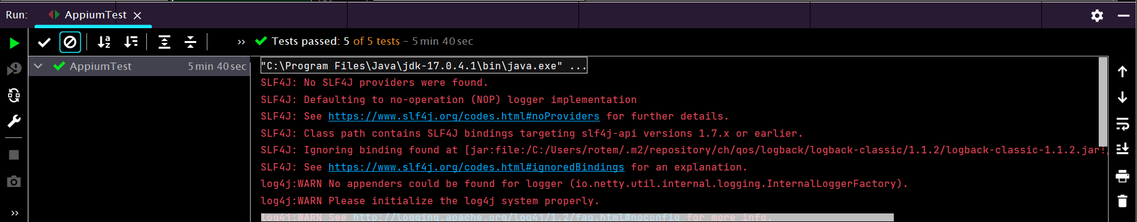All Application tests succeeded as can be seen in Figure ‎2‑4.

Figure ‎2‑4: Appium Tests success

## Tests Performed using SQLite:

Using Java code and connector to SQLite we created a database and inserted a few users as expected, an example for the created table “users” can be seen in Figure ‎2‑5.

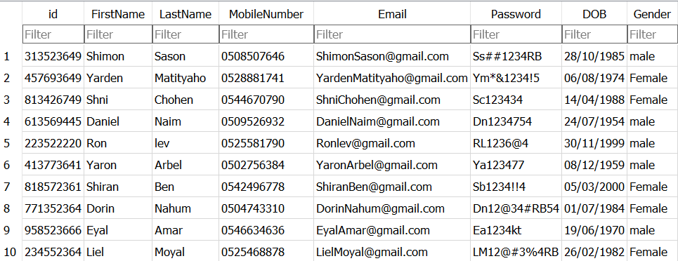

Figure ‎2‑5: Table “users” taken from SQLite.

Tests description for SQL Database tests can be seen in Table ‎2‑3.

Table ‎2‑3: SQL tests using SQLite and Java

|  |  |  |  |
| --- | --- | --- | --- |
| **Name Of Test** | **Description** | **Failed/ Succeeded** | **Note** |
| testID | id is valid | V | contains only number and exactly 9 characters |
| testFirstName | First Name is valid | V | contains only Characters and starts with capital letter and the rest are lower case letters |
| testLastName | Last Name is valid | V | Contains only Characters and starts with capital letter and the rest are lower case letters |
| testMobileNumber | Mobile Number is valid | V | Starts only with 050||052||054 and contains exactly 10 numbers as characters |
| testEmail | Email is valid | V | Contains '@' and ends with '.com' |
| testPasswordStrong | Password is Strong and valid | V | Contains Uppercase and lowercase and a number, and at least 6 characters |
| testPasswordMedium | Password is Medium and valid | V | Two conditions from the strong, and at least 6 characters |
| testDOB | Date of Birth is valid | V | Date exists and it is in the past |

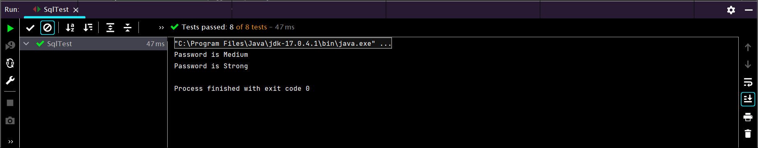All SQL tests succeeded as can be seen in Figure ‎2‑6.

Figure ‎2‑6: SQL Tests success

# Summery and conclusion:

During the last ten months, I participated in a QA course with automation and development in which I learned about a wide variety of topics and tools such as QA methodologies, SQL, software testing in the Web&Mobile environment with Android Studio, software development in the Java language, software and techniques for automation testing that are the most sought after in the field to achieve a more efficient and accurate test More such as Selenium, Jemeter, Postman, Appium.

The course was challenging and developing and gave me strong foundations in the field of QA and software development, which gave me a deeper understanding of the world of testing.

The advantage of this course is that it covers two major areas of the software world, allowing me to use the knowledge I've acquired in both development and testing to write higher and better code.  
and to perform tests more accurately and efficiently.

I would be happy if there were also face-to-face meetings during the course, I believe it would have helped to be in closer contact with the instructors and the other students.

In addition, I would be happy if more time could be allocated to the topic of automation because the more time we invest and the more we practice different tools and methods, the more professional we will be and achieve better results.

I also want to point out that the lecturers were approachable, kind, and willing to help and explain in an extraordinary way!

In conclusion, I highly recommend the course and look forward to taking the knowledge and tools I received in the course and using them in the industry.

# Bibliography

1. *Bank "Otsar Ha-Hayal"*. (n.d.). Retrieved from https://www.bankotsar.co.il/wps/portal/
2. *Facebook Login and Sign in page*. (n.d.). Retrieved from https://www.facebook.com/index.php
3. *GitHub: Memory Game*. (n.d.). Retrieved from https://github.com/sromku/memory-game